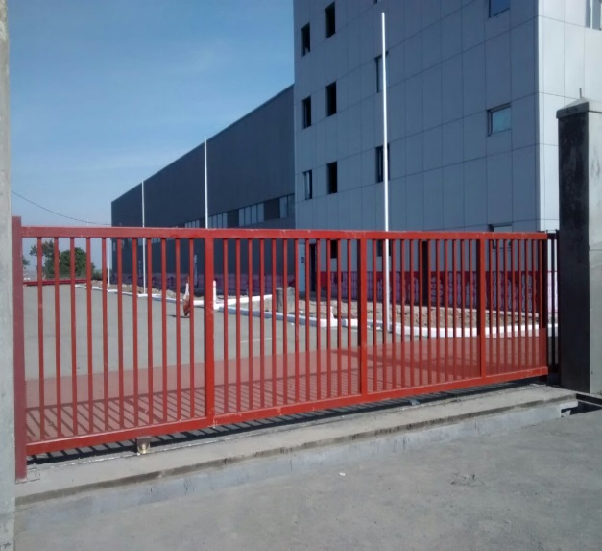
NIHVA USP:-
- Motorized or manual drive system propels the gate along.
- Constructed from sturdy materials like steel or aluminium.
- Obstacle detection sensors prevent accidents by halting gate movement.
- Includes latch or electronic system for secure closure.
- Operated via control panel or remote transmitter for convenience.
- Length of gate can be fabricated from 1000mm - 15000mm.
- Can be fabricated for gates up to 18000 kg weights capacity.
- Bottom rail made up of polished bright bar supported with heavy duty beam.

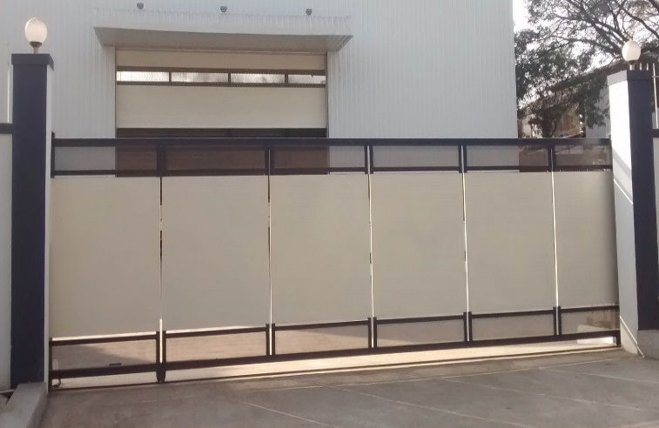
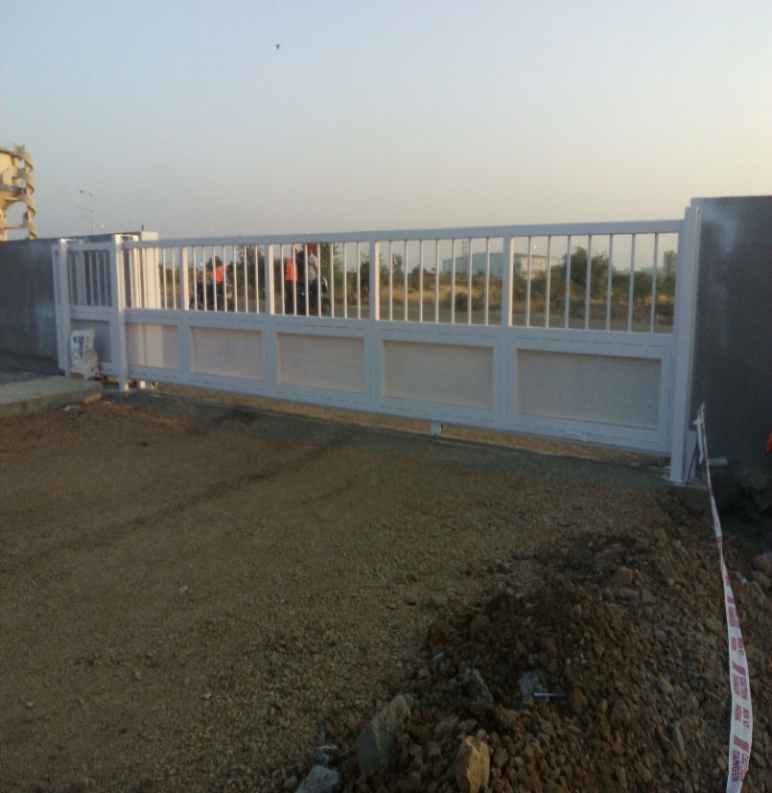
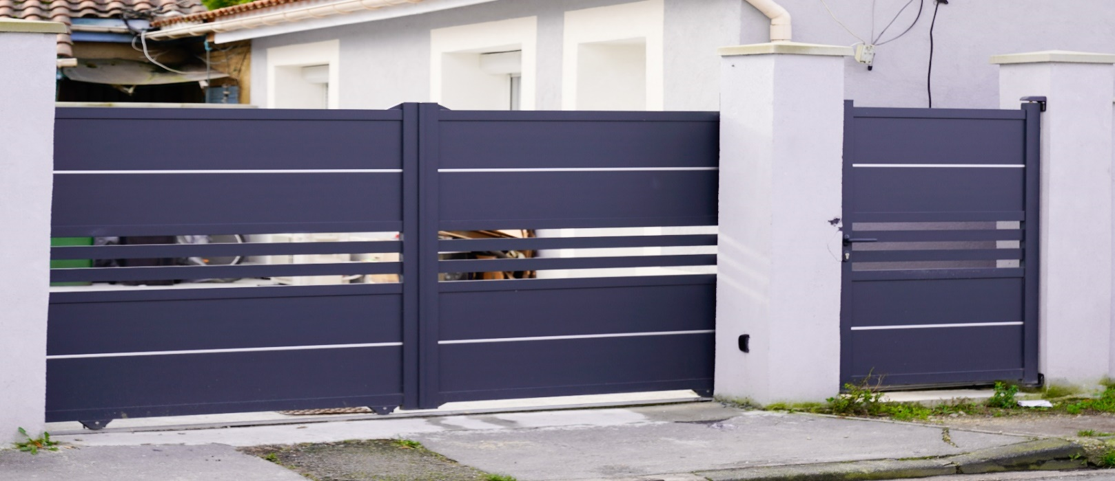
Technical Specification | Description
Product | Motorized Sliding Gate
Dimensions
Width Min. /Max. | - Single Leaf : 1000/15000mm  - Double Leaf :1000/30000mm
Height Min. /Max. | - 1000/3000mm  - Larger Dimension on request
Opening | - Horizontal
Mounting Location | - Inside/ Outside
Material | - Stainless Steel, Hot dip Galvanized
Sheets | - M.S/GI/Perforated /Aluminum sheets/Wood.
Ornamental Designs | - On Request or as per client design.
Options Available  (as per requirement) | - Spikes /Wicket gate/Side Gates in the similar pattern as the main gate any type of Customized Design can be made on request.
Automation
Drive Unit | - Motorized / Manual
Emergency Operation | - Manual release knob.
Accessories (Optional) | Operational  - Additional Push Button  - Key switch  - Remote Control with receiver  - Magnetic Loop Detector | Safety  - Safety Photocell  - Vertical Safety  - Edge Sensor  - Flashing Light
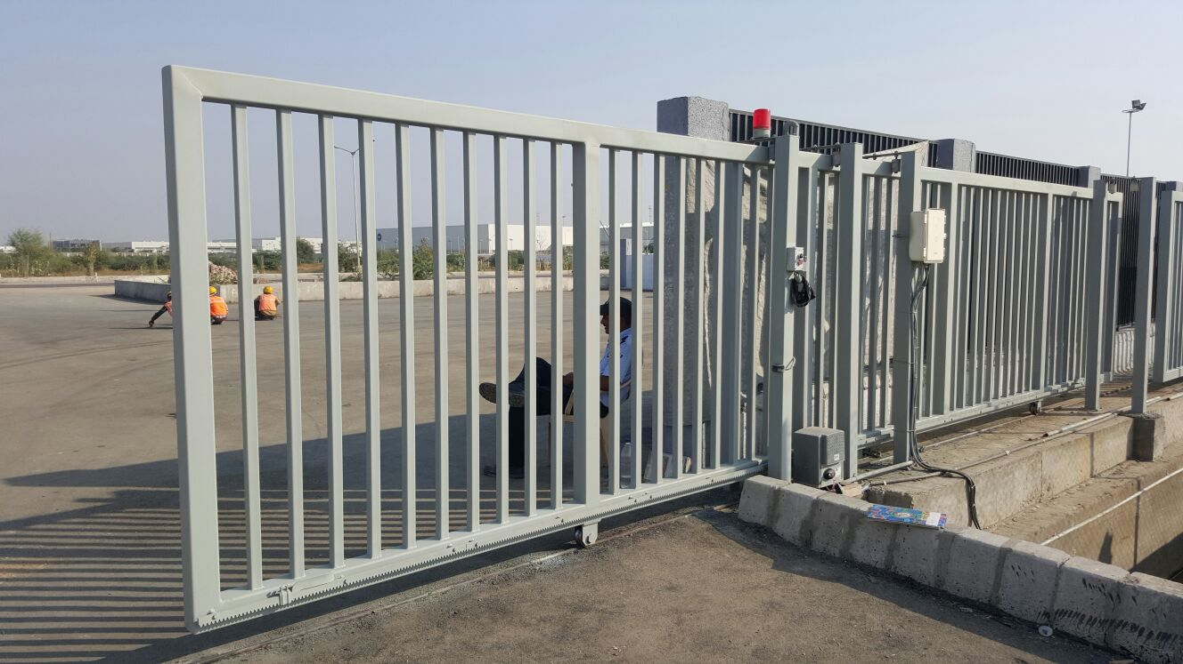
Sliding Gate
- Smooth Safe & economical operation.
- Varied lengths of gates can be fabricated from 1000mm - 12000mm.
- Can be fabricated for gates up to 18000 kgs weights capacity.
- Bottom rail made up of polished bright bar supported with heavy duty beam.
- Bottom roller with high precision bearings
Sliding Gate
- Smooth Safe & economical operation.
- Varied lengths of gates can be fabricated from 1000mm - 12000mm.
- Can be fabricated for gates up to 18000 kgs weights capacity.
- Bottom rail made up of polished bright bar supported with heavy duty beam.
- Bottom roller with high precision bearings
Sliding Gate
- Smooth Safe & economical operation.
- Varied lengths of gates can be fabricated from 1000mm - 12000mm.
- Can be fabricated for gates up to 18000 kgs weights capacity.
- Bottom rail made up of polished bright bar supported with heavy duty beam.
- Bottom roller with high precision bearings
Sliding Gate
- Smooth Safe & economical operation.
- Varied lengths of gates can be fabricated from 1000mm - 12000mm.
- Can be fabricated for gates up to 18000 kgs weights capacity.
- Bottom rail made up of polished bright bar supported with heavy duty beam.
- Bottom roller with high precision bearings
Sliding Gate
- Smooth Safe & economical operation.
- Varied lengths of gates can be fabricated from 1000mm - 12000mm.
- Can be fabricated for gates up to 18000 kgs weights capacity.
- Bottom rail made up of polished bright bar supported with heavy duty beam.
- Bottom roller with high precision bearings
Sliding Gate
- Smooth Safe & economical operation.
- Varied lengths of gates can be fabricated from 1000mm - 12000mm.
- Can be fabricated for gates up to 18000 kgs weights capacity.
- Bottom rail made up of polished bright bar supported with heavy duty beam.
- Bottom roller with high precision bearings

